AI WeatherWise – Smart Weather Analysis and Personalized Recommendations

Team ID : SWTID-2026-6039
Team Size : 4
Team Leader : RISANA PARVEEN S
Team member : GOWSHIKA J
Team member : MYNIJA SRI B
Team member : YOKESHWARI E
Department: 3rd B.sc(Computer Science)
College: Sri Kanyaka Parameswari Arts & Science college for women
GitHub link: https://github.com/risanaparveen88-stack/AI_WeatherWise_API
Demo video link: https://drive.google.com/file/d/1NPOsm8IZ2c9L6lxNIOKIprpSSKR2e8fH/view?usp=drivesdk

Project Description
AI WeatherWise is a dynamic RESTful backend platform developed using Node.js and Express.js. It uses MongoDB and Mongoose ODM for data persistence.
The system fetches real-time weather information from the OpenWeatherMap API and analyzes the weather data using Groq AI (Llama / GPT architecture). It provides accurate weather summaries and customized lifestyle recommendations related to Clothing, Activities, and Health Tips.
The system also accepts an optional "purpose" input based on the user's specific requirement and dynamically generates a personalized purpose-based recommendation.
The platform includes secure JWT authentication, bcrypt password hashing, dynamic search history tracking using the WeatherSearch collection, robust error handling, and API fallback mechanisms.

Scenario-Based Case Study
Background
People who travel outdoors, photographers, athletes, and daily commuters often need accurate weather information when travelling to different locations.
Simply viewing raw weather data such as temperature and humidity does not help users easily decide whether the weather is suitable for their specific activity.

Problem
- Only raw weather data is available, without actionable recommendations on how to use the information.
- There is no natural-language advice about what clothes to wear according to the weather.
- Users do not receive suggestions about suitable activities based on the weather conditions.
- Health and safety recommendations related to weather conditions are not provided.
- Personalized advice for a specific purpose, such as photoshoot, cricket, trekking, or travelling, is not available.
- A secure platform is required to track and maintain previously searched weather details.

Solution
AI WeatherWise provides a centralized backend service that retrieves accurate weather data through the OpenWeatherMap API and processes it using AI.
The weather information is handled using Mongoose schemas and stored in MongoDB.
The AI integration generates standard recommendations under the following categories:
- Clothing
- Activities
- Health Tips
- Purpose-based recommendations
The recommendations are returned to the client in a clean JSON format.

Usage
End User / Client
- Users can access public weather information.
- Users can create an account and log in securely.
- Logged-in users can receive personalized weather recommendations.
- Users can specify a particular purpose and receive customized guidance.

Developer / Evaluator
Developers or evaluators can use Thunder Client or Postman to test:
- System health
- User authentication
- JWT token verification
- Weather APIs
- Search history APIs
- AI recommendation endpoints

Outcome
Users do not need to spend time interpreting raw weather numbers.
The system provides context-aware AI recommendations that help users understand the weather and make appropriate decisions for their activities.
The Mongoose schemas help maintain data consistency and integrity in the database.

1. Software and Hardware Requirements
Software Requirements
- Operating System: Windows 10/11, macOS, or Linux
- Node.js (v18 or v20+): Used for backend server logic and asynchronous request handling
- npm (v9 or v10+): Used for managing project dependencies
- MongoDB and Mongoose ODM: Used for NoSQL database storage and database interaction
- Groq API / OpenAI API Client: Used as the AI model engine
- API Testing Tool: Thunder Client (VS Code Extension) or Postman
- Code Editor: Visual Studio Code

Hardware Requirements
- Processor: Intel Core i3/i5 (8th Generation or above) / AMD Ryzen 5
- RAM: Minimum 8 GB for smoothly running MongoDB, Node.js, and browser instances
- Storage: Minimum 2 GB of free disk space

Epic 1: PROJECT ARCHITECTURE
The AI WeatherWise application follows the Model-View-Controller (MVC) architectural pattern to completely decouple core business logic from data management. The system utilizes Mongoose ODM to persist user profiles and search histories into MongoDB, while integrating OpenWeatherMap and Groq AI services for real-time intelligence.

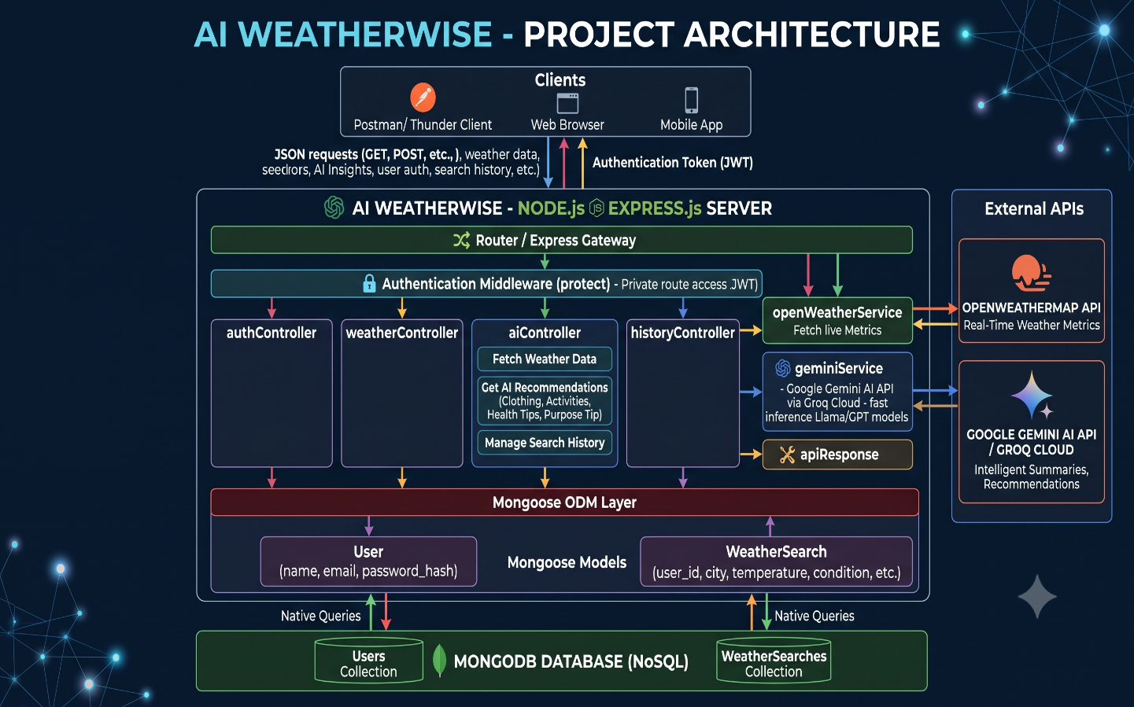
Components Defintion
- Interface: API testing tools such as Postman or Thunder Client query distinct route paths to extract JSON entities.
- Express Server Gateway: Monitors network ports, maps explicit HTTP methods (GET, POST, PUT, DELETE), parses JSON payloads, and handles CORS headers.
- Authentication & Role Matrix Middleware: Extracts tokens from headers, validates user context signatures, and evaluates if the specific role satisfies authorization thresholds for guarded resource paths.
- Granular Services (Logic Modules): Enforces isolated domain rules for blog lifecycles, comment queues, and system reporting indicators, alongside external weather and AI orchestrations.
- Database Interface Layer: Mongoose translates operational application logic into performant native MongoDB queries.

Entity-Relationship (ER) Diagram
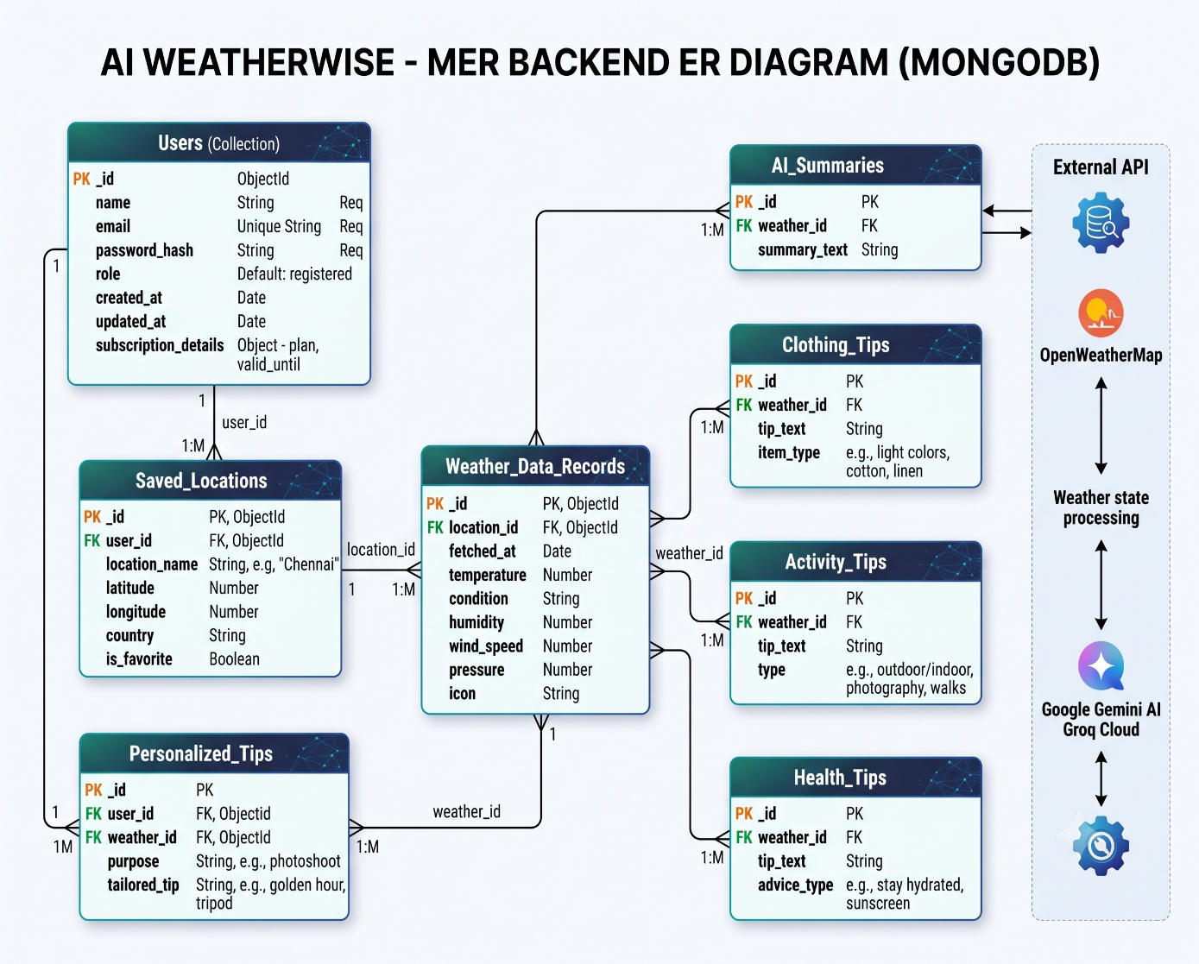
1. User Entity (users)
The users collection contains user account information.
- _id: ObjectId – Primary Key
- name: String – Required and trimmed
- email: String – Required, unique, and lowercase
- password: String – Hashed using bcryptjs
- createdAt: Timestamp
- updatedAt: Timestamp

2. WeatherSearch Entity (weathersearches)
The weathersearches collection stores users' weather search information.
- _id: ObjectId – Primary Key
- user: ObjectId – Reference to the User collection
- city: String – Required
- temperature: Number – Required
- condition: String – Required
- humidity: Number
- windSpeed: Number
- createdAt: Timestamp
- updatedAt: Timestamp
The timestamps are useful for sorting and retrieving recent searches.

Component Architecture Workflow
1. Client Interface
The client sends an HTTP JSON request through Thunder Client, Postman, or a frontend application.

2. Server Gateway and Middleware
Express.js receives and processes the incoming request.
The request is handled using:
- CORS middleware
- JWT Authentication middleware
- Request validation

3. Controller Orchestration
After the route receives the request, the corresponding controller is executed.

4. External Services
The system communicates with external services.

OpenWeatherMap API
The application requests real-time weather information such as:
- Temperature
- Humidity
- Weather condition
- Feels-like temperature
- Wind speed

Groq AI Service
The application sends a structured prompt to the Groq AI service.
The AI generates weather recommendations in JSON format.

5. Persistence Layer
Weather search details are automatically stored in MongoDB along with the reference of the logged-in user.

Roles and Responsibilities
Admin:
- Responsible for user account management, including creating, deleting, or suspending accounts.
- Oversight of external weather API health, rate limits, and system logs to monitor app performance.
- Monitoring and managing database integrity for user preferences, historical logs, and saved profiles.

Registered User:
- Responsible for creating and maintaining a list of favorite or multi-city locations for quick access.
- Initiating requests for real-time weather metrics, including temperature, hourly/daily forecasts, UV index, humidity, and radar maps.
- Interacting with personalized features such as weather-related clothing suggestions, pollination levels, and severe weather alerts.
- Managing their own authentication credentials, app preferences (such as dark mode UI), and customized widget layouts.

User Flow
- User logs in or registers securely using their authentication credentials.
- User adds and saves favorite cities or enables multi-city support via the interface.
- User fetches current weather metrics, hourly forecasts, and advanced metrics (such as AQI, UV index, and radar maps) for the selected location.
- User requests personalized insights, such as weather-related clothing suggestions, severe weather push notifications, or offline cached data views.
- System validates the request (via tokens/JWT), fetches real-time data from the weather APIs and database, and returns the updated dashboard, charts, and widget layouts.

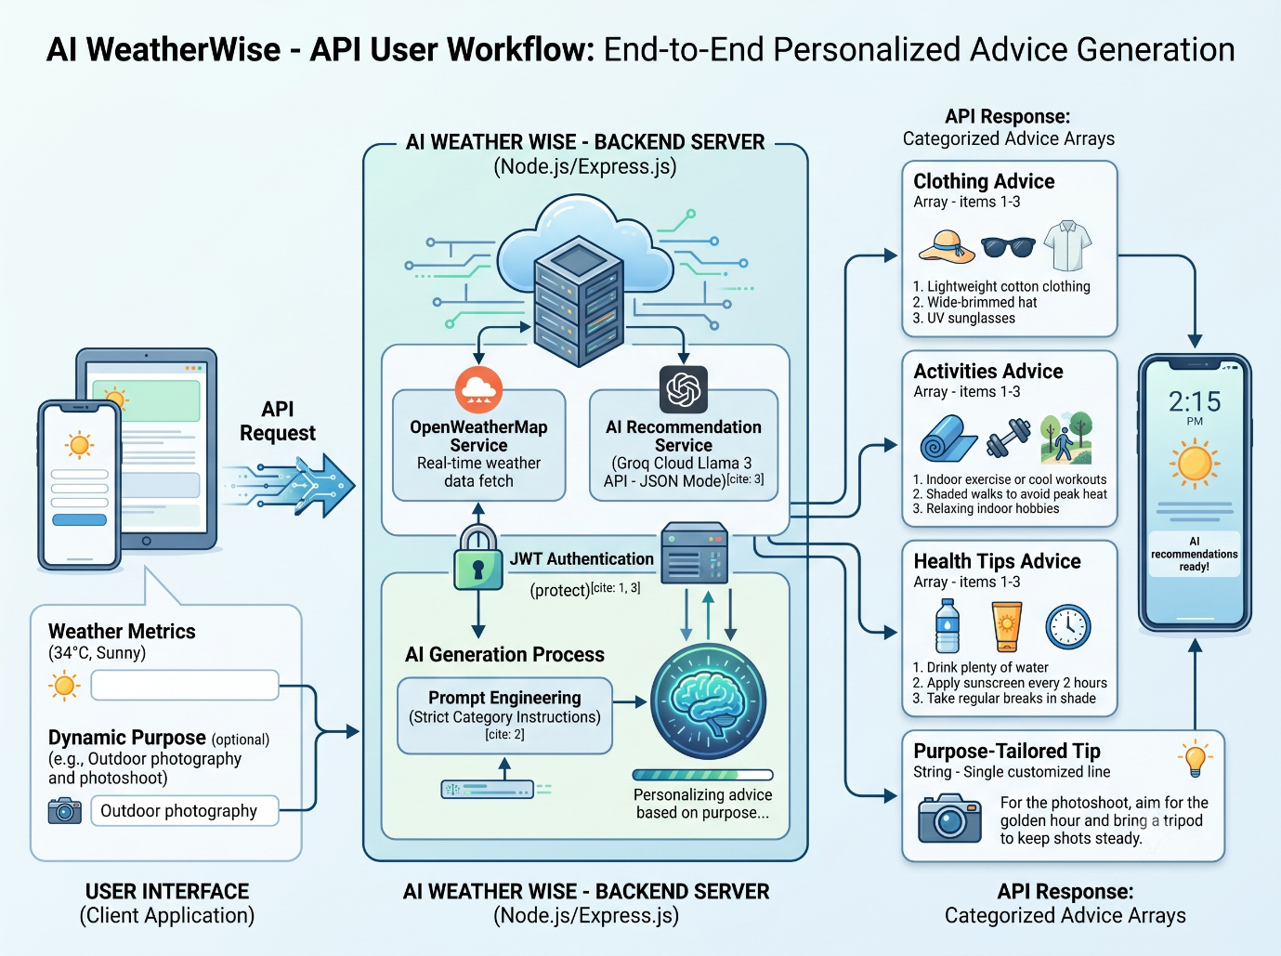

MVC Architecture Pattern

The application follows the Model-View-Controller (MVC) architectural pattern.

Model Layer
The Model Layer defines the database structure using Mongoose Schemas.
The main models are:
- User
- WeatherSearch

Controller Layer
The Controller Layer handles the main business logic of the application.
It receives requests, communicates with the OpenWeatherMap API and AI services, processes the results, and prepares the response.

View Layer / API Router Gateway
Since this is a headless backend architecture, there is no traditional graphical View Layer.
Instead, API routes act as the interface between the client and server.
The main API routes are:
- /api/auth
- /api/weather
- /api/ai
- /api/history
These routes communicate with the client using JSON responses.

EPIC 2: PROJECT SETUP AND CONFIGURATION
2.1 Project Initialization
The AI WeatherWise backend project was initialized using Node.js and Express.js. The project follows a modular backend structure to separate configuration, controllers, middleware, models, routes, services, utilities, and validators.
The project was created using the following commands:
mkdir ai-weatherwise-api
cd ai-weatherwise-api
npm init -y
The required backend dependencies were installed using npm:
npm install express mongoose dotenv cors bcryptjs jsonwebtoken axios
Development dependencies were installed for easier development and server monitoring:
npm install --save-dev nodemon
The backend application runs on a Node.js environment and uses Express.js to handle HTTP requests and API routing.

2.2 Project Directory Structure
The project is organized into the following structure:
ai-weatherwise-api/
│
├── node_modules/
│
├── src/
│ │
│ ├── config/
│ │ ├── db.js
│ │ └── env.js
│ │
│ ├── controllers/
│ │ ├── adminController.js
│ │ ├── aiController.js
│ │ ├── authController.js
│ │ ├── historyController.js
│ │ ├── locationController.js
│ │ └── weatherController.js
│ │
│ ├── middleware/
│ │ ├── authMiddleware.js
│ │ ├── errorMiddleware.js
│ │ ├── rateLimitMiddleware.js
│ │ ├── roleMiddleware.js
│ │ └── validationMiddleware.js
│ │
│ ├── models/
│ │ ├── Location.js
│ │ ├── SearchHistory.js
│ │ ├── User.js
│ │ ├── WeatherCache.js
│ │ └── WeatherSearch.js
│ │
│ ├── routes/
│ │ ├── authRoutes.js
│ │ ├── historyRoutes.js
│ │ ├── locationRoutes.js
│ │ └── weatherRoutes.js
│ │
│ ├── services/
│ │ ├── cacheService.js
│ │ ├── geminiService.js
│ │ ├── openWeatherService.js
│ │ └── recommendationService.js
│ │
│ ├── utils/
│ │ ├── apiResponse.js
│ │ ├── asyncHandler.js
│ │ ├── generateToken.js
│ │ └── sanitize.js
│ │
│ ├── validators/
│ │ ├── authValidator.js
│ │ ├── locationValidator.js
│ │ └── weatherValidator.js
│ │
│ ├── app.js
│ └── server.js
│
├── .env
├── .gitignore
├── package-lock.json
├── package.json
└── README.md

2.3 Environment Configuration
The project uses a .env file to store configuration values and API credentials separately from the application source code.
Example configuration:
PORT=5000
MONGO_URI=mongodb://127.0.0.1:27017/weatherwise
JWT_SECRET=your_super_secret_jwt_key
OPENWEATHER_API_KEY=your_openweather_api_key
GROQ_API_KEY=your_groq_api_key
The environment variables are loaded into the application using the dotenv package.
The configuration provides:
- PORT – Defines the port on which the Express server runs.
- MONGO_URI – Provides the MongoDB database connection string.
- JWT_SECRET – Used for generating and validating authentication tokens.
- OPENWEATHER_API_KEY – Used to access weather information from OpenWeatherMap.
- GROQ_API_KEY – Used for AI-based weather recommendations.
Sensitive API keys and authentication secrets are not hard-coded into the application source code.

2.4 Application Configuration
The src/config/ directory contains configuration-related files.
db.js
The db.js file manages the MongoDB connection using Mongoose.
const mongoose = require('mongoose');

const connectDB = async () => {
try {
const conn = await mongoose.connect(process.env.MONGO_URI);
console.log(`MongoDB Connected: ${conn.connection.host}`);
} catch (error) {
console.error(`Database connection error: ${error.message}`);
process.exit(1);
}
};

module.exports = connectDB;
env.js
The env.js file is used to manage and load environment configuration for the application.

2.5 Application Entry Points
The application contains two main files:
app.js
The app.js file configures the Express application, middleware, API routes, error handling, and other application-level settings.
server.js
The server.js file starts the backend server and establishes the database connection before accepting API requests.

EPIC 3: BACKEND DEVELOPMENT
3.1 Backend Architecture
The AI WeatherWise backend is developed using Node.js and Express.js. The application follows a modular architecture where different responsibilities are separated into controllers, routes, middleware, models, services, utilities, and validators.
The general request flow is:
Client
↓
Express Server
↓
Routes
↓
Validation / Authentication Middleware
↓
Controller
↓
Service Layer
↓
External API / Database / AI Service
↓
Controller Response
↓
Client
This structure improves maintainability, code organization, security, and scalability.
3.2 Controllers
The controllers directory contains the main business logic of the application.
authController.js
Handles user authentication-related operations such as:
- User registration
- User login
- Password verification
- JWT token generation

weatherController.js
Handles weather-related requests and communicates with the weather service to obtain current weather information.

aiController.js
Handles AI-powered weather recommendations. It receives weather information and optional user purpose and generates personalized recommendations through the AI

service.
The recommendations include:
- Weather summary
- Clothing suggestions
- Activity suggestions
- Health tips
- Purpose-specific recommendations

historyController.js
Handles retrieving the user's previous weather searches and search history.

locationController.js
Handles location-related operations used by the application.

adminController.js
Handles administrative operations provided by the backend.

3.3 Middleware
The middleware directory contains reusable request-processing components.
authMiddleware.js
Provides JWT-based authentication and protects routes that require a logged-in user.

errorMiddleware.js
Provides centralized error handling for API requests and prevents application errors from producing unstructured responses.

rateLimitMiddleware.js
Helps control the number of requests made to the API within a specific period.

roleMiddleware.js
Provides role-based access control for routes that require specific user permissions.

validationMiddleware.js
Processes validation results and returns appropriate errors when request data does not satisfy the required validation rules.

3.4 Routes
The routes directory defines the API endpoints and connects them with the appropriate controllers.
authRoutes.js
Provides authentication-related endpoints such as:
POST /api/auth/register
POST /api/auth/login

weatherRoutes.js
Provides endpoints for retrieving weather information.
Example:
GET /api/weather/:city

historyRoutes.js
Provides endpoints for accessing user search history.
Example:
GET /api/history

locationRoutes.js
Provides endpoints for location-related operations.

3.5 External Weather API Integration
The openWeatherService.js service communicates with the OpenWeatherMap API.
The service retrieves weather information such as:
- Temperature
- Weather condition
- Humidity
- Wind speed
- Feels-like temperature
The weather service separates external API communication from the controller logic.

3.6 AI Recommendation Service
The geminiService.js and recommendationService.js files provide AI-related functionality.
The AI service processes weather information and generates natural-language recommendations.
The recommendation categories include:
Summary
Clothing
Activities
Health Tips
Purpose Tip
For example, when the user provides:
{
"temperature": 34,
"condition": "Sunny",
"purpose": "Outdoor photography and photoshoot"
}
the system can generate personalized recommendations based on the weather conditions and the specified purpose.

3.7 Authentication and JWT
The application uses JSON Web Tokens (JWT) for user authentication.
After successful registration or login, the server generates a JWT token.
The client sends the token in subsequent protected requests using:
Authorization: Bearer <JWT_TOKEN>
The authentication middleware validates the token before allowing access to protected resources.

3.8 Input Validation
The validators directory contains validation logic for incoming API requests.
The project contains:
authValidator.js
locationValidator.js
weatherValidator.js
These validators help ensure that incoming request data follows the expected format before it reaches the controller layer.

3.9 Utility Functions
The utils directory contains reusable application utilities.
apiResponse.js
Provides a consistent structure for successful and error API responses.
asyncHandler.js
Simplifies asynchronous controller error handling.
generateToken.js
Provides JWT token generation functionality.
sanitize.js
Helps sanitize input data before processing it.

3.10 Caching Mechanism
The project contains a dedicated cacheService.js and WeatherCache.js model.
The caching mechanism can be used to temporarily store previously retrieved weather information and reduce unnecessary repeated requests to the external weather API.

EPIC 4: DATABASE CONFIGURATION
4.1 MongoDB Configuration
The AI WeatherWise application uses MongoDB as its NoSQL database.
MongoDB is connected to the Node.js backend using Mongoose ODM.
The database connection is configured using the MONGO_URI environment variable:
MONGO_URI=mongodb://127.0.0.1:27017/weatherwise
The database name used by the project is:
weatherwise
4.2 Mongoose ODM
Mongoose is used to define database schemas and interact with MongoDB.
It provides:
- Schema definition
- Data validation
- Model creation
- Database queries
- Relationships using ObjectId references
- Timestamp management
The database-related models are stored inside:
src/models/

4.3 Database Models
The project contains the following Mongoose models:
models/
├── Location.js
├── SearchHistory.js
├── User.js
├── WeatherCache.js
└── WeatherSearch.js

User.js
The User model stores registered user information.
Typical fields include:
_id
name
email
password
createdAt
updatedAt
Passwords are protected using password hashing before being stored in the database.

WeatherSearch.js
The WeatherSearch model stores weather search information.
The model can contain:
_id
user
city
temperature
condition
humidity
windSpeed
createdAt
updatedAt
The user field associates the weather search with the corresponding authenticated user.

SearchHistory.js
The SearchHistory model is used to maintain information about previous user searches.
It supports the application's search-history functionality and allows recent searches to be retrieved for an authenticated user.

Location.js
The Location model stores location-related information used by the application.
It supports location management and location-based weather operations.

WeatherCache.js
The WeatherCache model is used to store cached weather information.
This supports the application's caching mechanism and can reduce unnecessary repeated calls to the external weather service.

4.4 Database Relationship
The main relationship between users and weather searches can be represented as:
User
│
│ 1
│
│
│ Many
▼
WeatherSearch
A single user can have multiple weather search records.
The relationship is implemented using MongoDB ObjectId references.
Example:
user: {
type: mongoose.Schema.Types.ObjectId,
ref: 'User'
}

4.5 Search History Retrieval
The backend retrieves recent search history using the authenticated user's ID.
Example logic:
const history = await WeatherSearch.find({
user: req.user._id
})
.sort({ createdAt: -1 })
.limit(5);
This retrieves the latest five weather search records for the logged-in user.

4.6 Database Timestamp Management
The Mongoose schemas use timestamps to automatically maintain:
createdAt
updatedAt
These timestamps help track when database records were created and modified.
They are particularly useful for sorting recent weather searches and maintaining search history.

4.7 Database Workflow
The overall database workflow is:
User Request
↓
Express Route
↓
Authentication / Validation
↓
Controller
↓
Mongoose Model
↓
MongoDB
↓
Database Result
↓
Controller
↓
JSON Response
This database configuration provides structured persistence for user accounts, weather searches, search history, locations, and cached weather information.

Epic 5: API Testing and Execution Verification
API Testing Overview
The AI WeatherWise REST APIs are tested using Thunder Client/Postman to verify the functionality, authentication, validation, and responses of the backend.
API testing is performed by sending HTTP requests to the local Express server and checking the returned status codes and JSON responses.
The major APIs tested include:
- User Registration API
- User Login API
- Weather API
- AI Weather Recommendation API
- Search History API
- Location APIs
1) User Registration
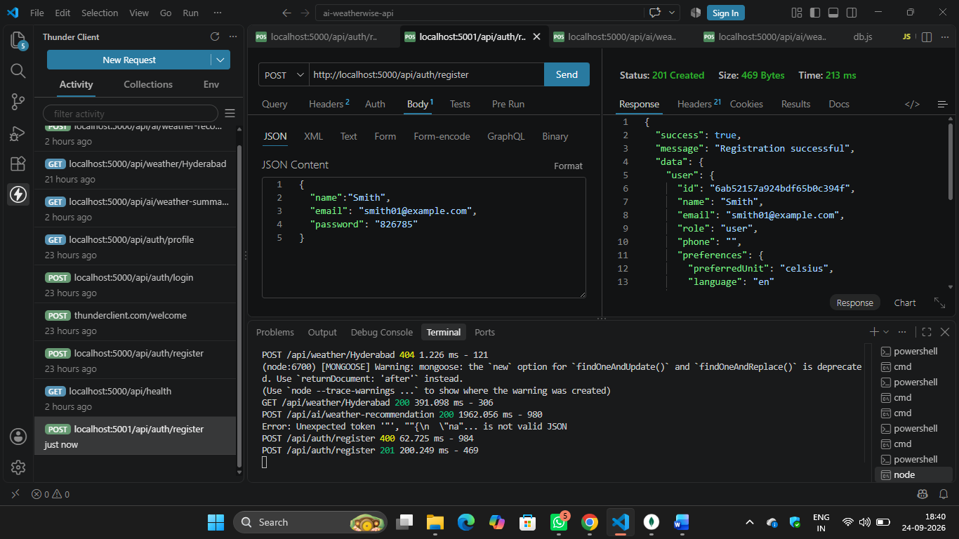
2) User Login
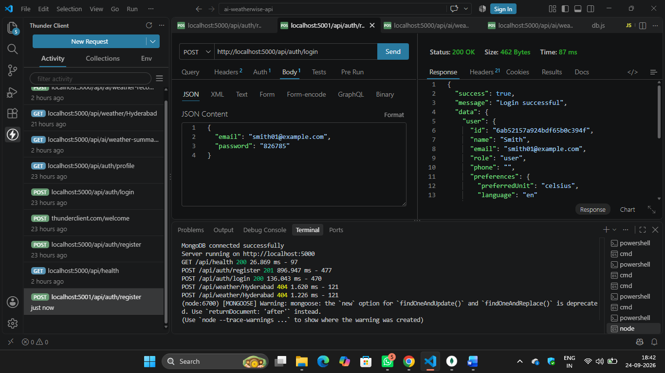

3)Real-Time Weather Fetch 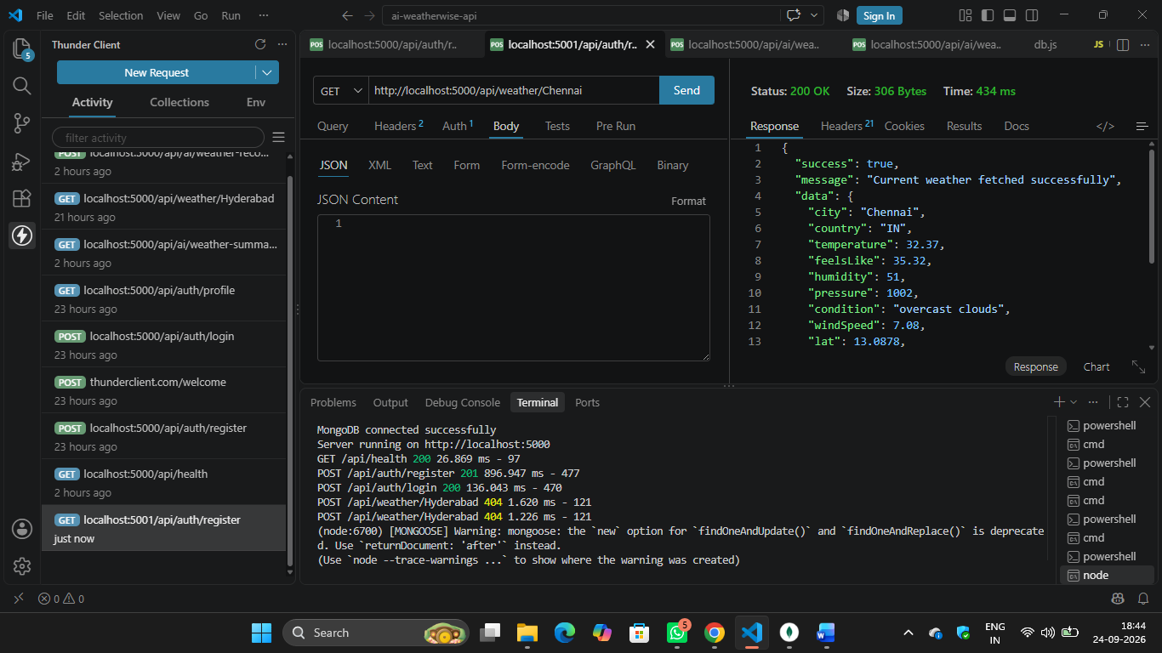

4) Get user profile
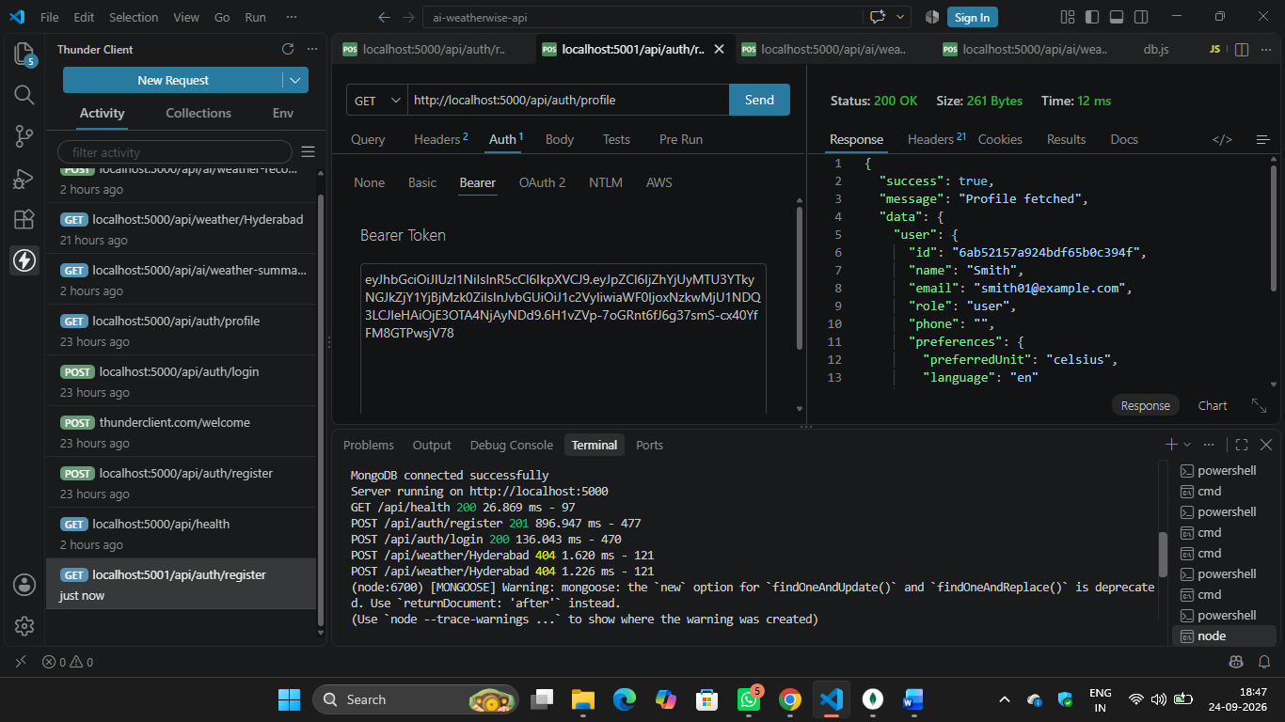

5) Add favorite location
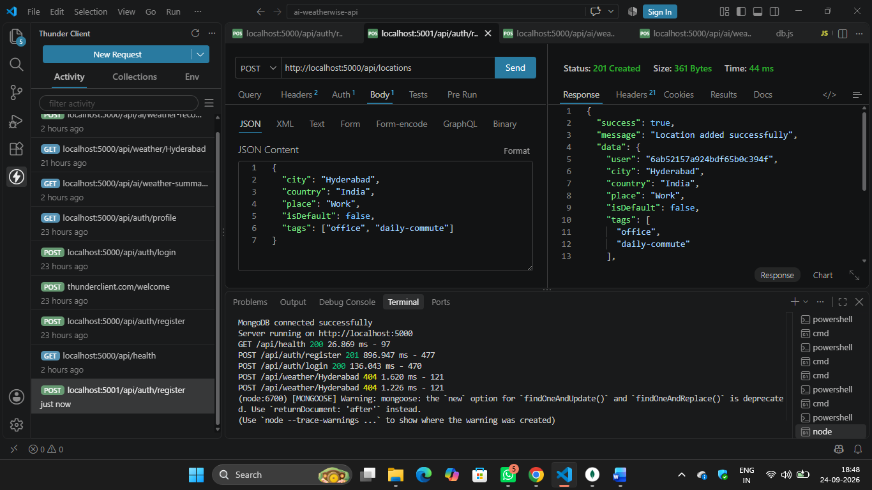
6) Get favorite locations
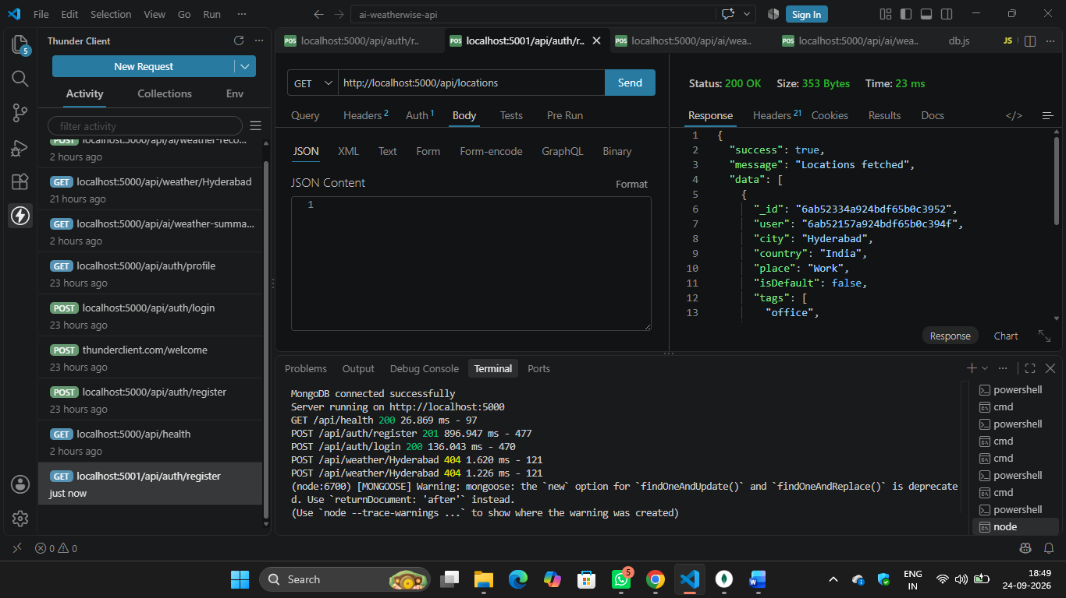

7) AI weather summary
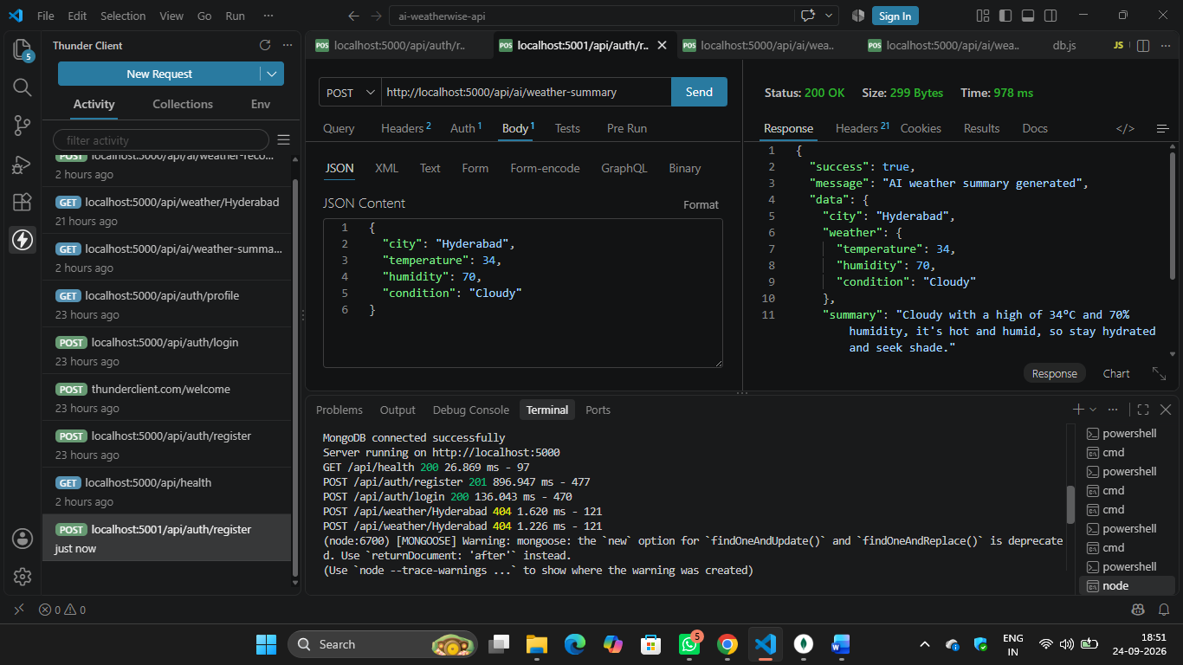
8) Standard AI Weather Recommendation (Without Purpose)
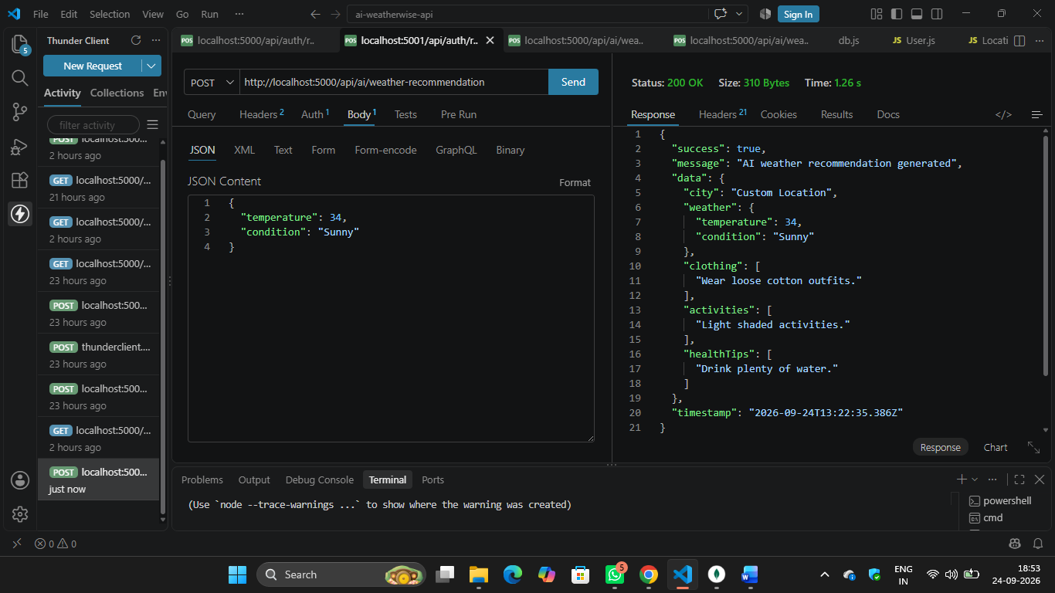

9) Personalized Recommendation (With Custom Purpose)
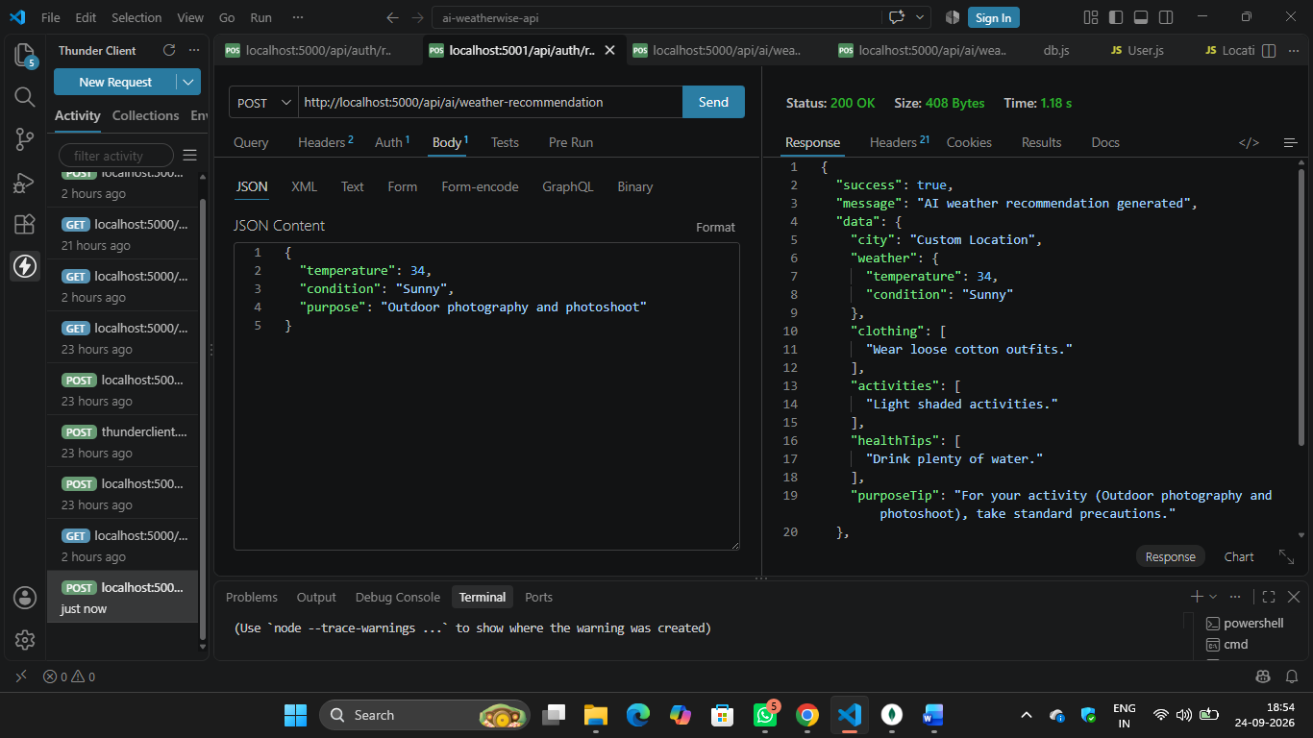
10) User Search History Tracking
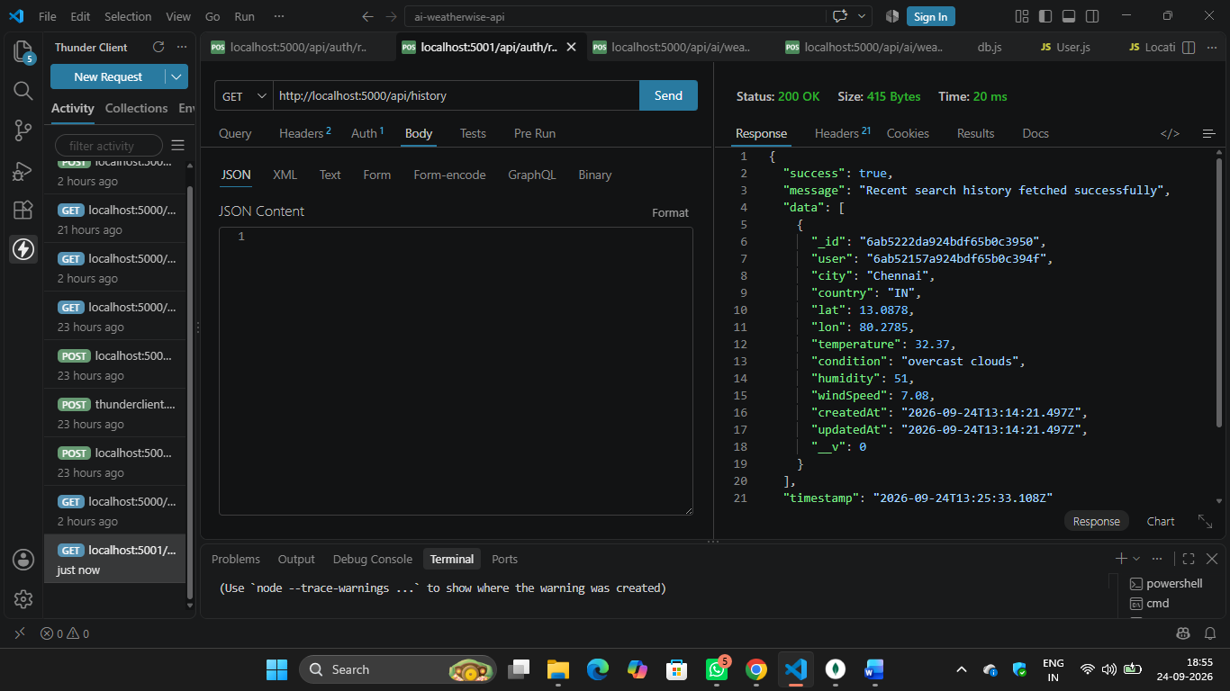

Conclusion
AI WeatherWise is a RESTful backend platform that combines Node.js, Express.js, MongoDB, Mongoose, OpenWeatherMap API, JWT Authentication, and Groq AI to provide intelligent weather-based recommendations.
The system converts raw weather information into useful recommendations related to clothing, activities, health, and user-specific purposes.
It also provides secure authentication and maintains users' recent weather search history, making the platform useful for travellers, photographers, athletes, commuters, and other outdoor users.

